**Identifying Reasoning Fallacies in a Comprehensive Taxonomy of Contrarian Claims about Climate Change**

Ruby Flack1, John Cook2, Peter Ellerton3, David Kinkead4, Travis Coan5, Constantine Boussalis6, Mirjam Nanko5, Ailie Gallant7, Roger Dargaville8

1. Global Challenges, Monash University, Australia
2. Monash Climate Change Communication Research Hub, Monash University, Australia
3. Critical Thinking Project, University of Queensland, Australia
4. Centre for Critical and Creative Thinking, University of Queensland, Australia
5. Department of Politics and the Exeter Q-Step Centre, University of Exeter, UK
6. Department of Political Science, Trinity College, Dublin, Ireland
7. School of Earth, Atmosphere and Environment, Monash University, Australia
8. Department of Civil Engineering, Monash University, Australia

# **Abstract**

While climate change grows as an environmental and societal emergency, misinformation about climate change continues to hinder necessary action and democratic decision-making. An important step in neutralising climate misinformation is identifying the rhetorical techniques and logical fallacies used to distort climate science and confuse the public. We expand on previous critical thinking research, developing a detailed methodology for deconstructing and analysing real-world misinformation. We apply our extended methodology to a comprehensive taxonomy of contrarian climate claims, finding reasoning fallacies in all claims. Cherry picking and oversimplification are the most common fallacies. Contrarian claims regarding climate solutions, while more nuanced than explicit science denial, are still rife with misleading fallacies. The ubiquity and complexity of misinformation in online spaces and public discussion necessitates holistic, interdisciplinary solutions that can be scaled up to meet the immensity of the problem. This research is an example of such an interdisciplinary approach, combining machine learning, critical thinking, climate science, and climate solutions scholarship. Our results are presented as a resource for countering contrarian claims, particularly useful in automated applications that detect and fact-check online climate misinformation in real time.

# 1. Introduction

Climate change is arguably the most pressing social, economic, and environmental problem facing society (Gasper et al., 2011; Abbass et al., 2022). Despite overwhelming scientific agreement on the reality of human-caused global warming (Cook et al., 2016; Myers et al., 2021), the general public is still polarised and confused about the issue (Leiserowitz et al., 2021). A significant contributing factor to this problem is climate change misinformation (McCright & Dunlap, 2011).

Climate misinformation (false information) and disinformation (intentionally false information) cast doubt about the reality of human-caused climate change or the efficacy of climate solutions, which can delay public support for climate action (Lamb et al., 2020). Misinformation reduces climate literacy (Ranney & Clark, 2016) and accentuates public polarisation (Cook et al., 2017). It has a subversive effect on how scientists report their results (Lewandowsky et al., 2015) and whether people discuss climate change with family and friends (Geiger & Swim, 2016). A consequence of misinformation for science communicators and educators is that it can cancel out attempts to communicate accurate information (Cook et al., 2017; McCright et al., 2016; van der Linden et al., 2017).

Given the ubiquity and complexity of online misinformation, interdisciplinary solutions are required that can be scaled up to address the immensity of the issue (Lewandowsky et al., 2017). The first step to neutralising the problem is better understanding the misinformation landscape. Previous studies have analysed climate misinformation targeting scientific topics (Rahmstorf, 2004), climate policy (Bonds, 2016; Capstick & Pidgeon, 2014; Lamb et al., 2020), and attacks on the reliability of climate scientists or climate science (Samoilenko & Cook, 2022). Coan et al. (2021) developed a comprehensive taxonomy of contrarian climate claims encompassing all of these themes (Figure 1). The taxonomy grouped a number of contrarian claims under five main categories: “global warming is not happening”, “global warming is not caused by humans”, “climate impacts are not bad”, “climate solutions won’t work”, and “the climate movement is unreliable.”

## Figure 1

*A taxonomy of contrarian climate claims developed by Coan et al. (2021)*

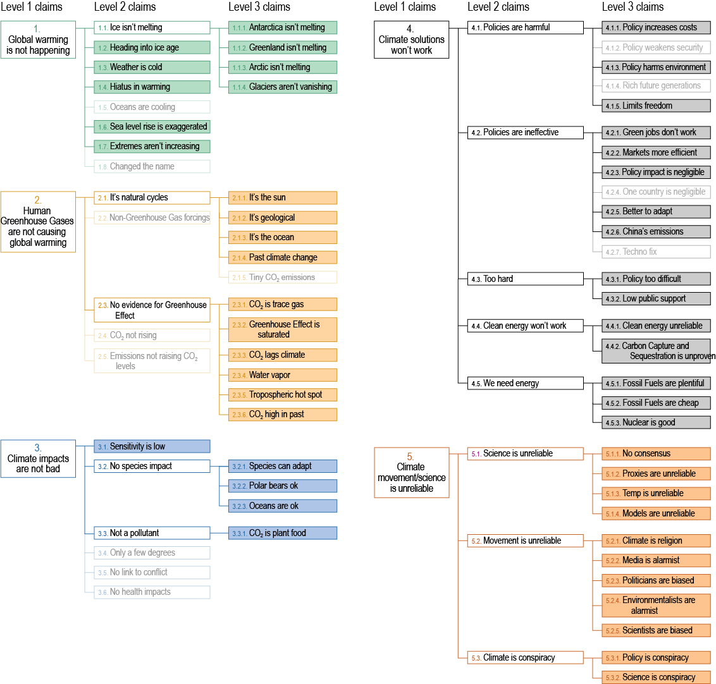

**Note.** *Only “childless claims” (claims with no sub-claims) were deconstructed in our analysis, indicated by solid colour boxes. “Parent claims” (claims with sub-claims) were excluded from deconstruction, indicated by empty boxes. All level 1 claims were parent claims, while all level 3 claims were childless claims. Greyed-out claims were excluded from this analysis due to insufficient exemple paragraphs.*

This taxonomy was developed as part of an effort to automate fact-checking of climate change misinformation, a goal described as the “holy grail of fact-checking” (Hassan et al., 2015). Computational methods have previously been used to analyse large datasets of climate misinformation, such as unsupervised learning to conduct topic analysis (Boussalis & Coan, 2016) and supervised learning to detect economic frames (Stecula & Merkley, 2019). Coan et al. (2021) detected specific contrarian claims using supervised learning, laying the foundation for automatic fact-checking of climate misinformation.

However, the scope of Coan et al. (2021) was limited to documenting claims made by climate contrarians without testing their veracity. Not all claims in their taxonomy were necessarily misinformation, with claims such as “carbon capture and sequestration is unproven” (4.4.2) and “nuclear energy is needed” (4.5.3) being topics of legitimate scholarly debate (Socolow & Glaser, 2009). To automatically fact-check contrarian climate claims, each claim needed to be assessed in order to identify which was misleading. Developing a system that objectively and reliably assesses the veracity of real-world claims is non-trivial. Graded frameworks (e.g., false, mostly false, partly false, true) are popular with fact-checkers but there is ambiguity and inconsistency in the middle grades (Graves, 2013; Lim, 2018). Terminology in fact-checking ratings is also important as labelling misinforming content as “partly true” or “barely true” conveys an unintentional impression of truth, which is why PolitiFact revised their terminology from “Barely True” to “Mostly False” (Adair, 2011).

We propose a system where claims are labeled as “misleading” if they contain reasoning fallacies. This follows the recommendations of Lim (2018) who argues that fact-checkers should report the logical fallacies in claims without necessarily assigning scores to these observations. Basing fact-checking on the presence of reasoning fallacies—in other words, “logic-checking”—resolves a number of challenges associated with fact-checking climate misinformation. Birks (2019) argues that a fact-checking approach should focus on what is pragmatically useful for people to make informed decisions—such as whether a claim is misleading—rather than define what counts as a ‘fact.’ Further, misinformation with hidden assumptions is common as misinformers often leave premises unstated in order to avoid being held to account (Birks, 2019). The critical thinking methodology from Cook et al. (2018) systematically adds hidden premises to a misleading argument in order to identify the claim’s intent.

Assessing claims based on the presence of reasoning fallacies also sidesteps the problem of verifying statements about the future, which are difficult to fact-check when there is no reality the claim could yet correspond to (Nieminen & Sankari, 2021). Predictive claims such as “we’re heading into an ice age” (claim 1.2 in the Coan et al. taxonomy) should be checkable if they contradict scientific research (Feulner and Rahmstorf, 2010). Similarly, hypothetical policy predictions such as “a specific policy will have a negligible impact on climate” (claim 4.2.3) may be strictly correct but still misleading because they commit the fallacy of impossible expectations—demanding that a lone policy single-handedly solve climate change.

Another challenge for fact-checkers is how to handle the rhetorical technique of paltering or cherry picking—the use of truthful statements to convey a misleading impression (Lewandowsky et al., 2016; Rogers et al., 2017). An example among contrarian climate claims is focusing on a single growing glacier while ignoring the majority of glaciers that are shrinking due to warming temperatures (claim 1.1.4). It may be true that a single glacier is growing but such a focus paints a misleading impression by ignoring the full body of evidence. The logic-checking approach appropriately tags text as misleading if it uses the paltering technique to paint a misleading impression even if the cherry picked evidence is factually true.

Fallacious arguments have been identified in misinformation across a range of scientific topics. Jacobson et al. (2007) used Gilovich’s taxonomy of reasoning flaws to analyse common arguments from the anti-vaccine movement. Diethelm & McKee (2009) identified the five denial techniques commonly found in science misinformation—fake experts, logical fallacies, impossible expectations, cherry picking, and conspiracy theories (summarised with the acronym FLICC; see Table S1 in the Supplementary Material for an extensive and updated list of definitions). Cook et al. (2018) analysed common climate myths, finding that each myth contained reasoning fallacies. To achieve this analysis, they developed a step-by-step methodology for systematically deconstructing and analysing potentially misleading statements.

This study adapts and extends the deconstruction methodology of Cook et al. (2018) and applies it to the comprehensive taxonomy of contrarian climate claims developed by Coan et al. (2021). As the scope of Coan et al. (2021) did not include testing the veracity of contrarian claims, we will identify which claims contain reasoning fallacies. This will enable us to list the most frequently employed fallacies in climate misinformation and how argumentation varies across different categories of climate misinformation. We will also provide the elements required for automated fact-checking of climate misinformation.

# 2. Methods

In this study, we use the term *argument* in its formal sense, meaning a connected series of statements used to establish a definite proposition (Chapman & Python, 1989). An argument is a logical structure that uses the truth of one or more statements (called premises) to establish the truth of another statement (called the conclusion). When analysing climate contrarian claims, the argument being deconstructed should accurately depict real-world misinformation in order to avoid the straw man fallacy.

[Coan et al. (2021](https://www.nature.com/articles/s41598-021-01714-4)) sampled content from conservative think-tank websites, a prolific source of climate misinformation (Al-wari et al., 2021; Boussalis & Coan, 2016) as well as denialist blogs. They compiled a training dataset with 7134 randomly selected paragraphs matched to contrarian claims. As their taxonomy of contrarian claims attempted to cover the landscape of climate misinformation, each claim could potentially represent a variety of arguments. For example, the level 3 claim “clean energy is unreliable” (4.4.1) includes examples such as “solar power doesn’t work at night”, “wind turbines kill birds”, and “renewables can’t deliver baseload power.” As these examples might consist of a variety of argument structures and different reasoning fallacies, we developed a methodology for devising an argument that reasonably represented the diversity of examples within each claim.

Example paragraphs were sampled from the Coan et al. (2021) training dataset for each contrarian claim. We only analysed “childless claims” in the taxonomy, meaning claims with no sub-claims (see Figure 1). This meant that a “parent claim” such as “ice isn’t melting” (1.1) was not deconstructed as it was sufficiently represented by its “children claims” such as “Antarctica isn’t melting” (1.1.1) and “Greenland isn’t melting” (1.1.2). Level 2 claims such as “hiatus in warming” (1.4) that were childless (no sub-claims) were deconstructed. However, claims with less than 10 paragraphs were considered infrequent enough to not warrant deconstruction and eliminated from this analysis, leaving 50 claims. We analysed sample paragraphs to identify exemplars that met a selection criteria determining suitability for deconstruction. The selection criteria included coherence, relevance to the contrarian claim, sufficient argument structure (e.g., including both premises and a conclusion), and explicit rather than ambiguous statements (see S2 in Supplementary Material for further explanation of the selection criteria).

Each exemplar paragraph was analysed using a streamlined version of the Cook et al. (2018) methodology. First, each exemplar was deconstructed into an argument structure consisting of premises and a conclusion. For example, the text “El Ninos and the opposite La Ninas apparently have a significant impact on global temperatures…” was deconstructed into an argument with the premise “Ocean cycles have a significant impact on global temperatures” leading to the conclusion “Humans are not causing global warming.”

Second, the inferential intent of the argument was categorised as either inductive—featuring probabilistic or provisional arguments—or deductive—featuring definitive conclusions. Contrarian climate claims are typically definitive, making absolute statements about the reality (or lack thereof) of human-caused climate change or the unviability of climate solutions. We were only interested in deductive arguments as inductive arguments weren’t as conducive to the deconstruction approach of Cook et al. (2018). If an inductive paragraph was identified during the deconstruction stage, a new examplar was selected.

Third, we assessed whether the argument was logically valid. In a deductively valid argument, if the premises are assumed (even hypothetically) to be true, then the conclusion must logically be true also. An example of a valid argument is “all fairies are green and Fred is a fairy, therefore Fred is green.” In this example, if both premises are assumed to be true, then the conclusion must also be true. In contrast, a logically invalid argument looks like “some fairies are green and Fred is red, therefore Fred is a fairy.” This argument is logically invalid because even if we assume all the premises are true, it doesn’t logically follow that the conclusion must be true. Just because Fred is red doesn’t necessarily mean that Fred is also a fairy.

If the argument was logically invalid, the next step was to identify the hidden premises required to make the argument valid. Arguments typically rely on unstated assumptions which need to be made explicit to make the argument valid. From the invalid example above, the hidden premise that would make the argument logically valid could be "if something is red, it is a fairy.” If Fred is red and all things red are fairies, then it logically follows that Fred must be a fairy. This step is often the most important step in the deconstruction process as unstated assumptions in misinformation typically contain fallacies and are revealed to be the misleading heart of a false argument.

After the exemplar paragraphs were deconstructed, the claims were categorised into deconstruction types based on the range of argument structures belonging to a specific claim. Table 1 summarises the contrarian claim deconstruction types.

## Table 1

*Contrarian claim deconstruction types*

| Type No. | Title | Description |
| --- | --- | --- |
| 1 | Homogeneous argument | All the exemplars were essentially the same argument. |
| 2 | Single general argument | The exemplars were similar enough that they could be represented by a single deconstructed argument. |
| 3 | Dominant argument | The exemplars were represented by more than one argument structure but with a single argument dominating. |
| 4 | Recategorized arguments | There were multiple argument structures with no dominant argument structure but with one or more of the argument structures belonging to a different claim in the taxonomy. |
| 5 | Multiple arguments | There were multiple argument structures that couldn’t be re-allocated to other claims in the taxonomy. |

Type 1 claims (homogeneous argument) featured exemplars consisting of essentially the same argument. An example of a type 1 claim was “CO2 lagging temperature disproves the warming effect of CO2” (2.3.3), a false choice argument which consistently appeared in essentially the same form. Type 2 claims (single common argument) featured a range of exemplars that were similar enough that all could be represented by a common argument structure (Figure 2a). For example, the claim “warming is caused by geological factors” (2.1.2) took forms such as “ocean warming is due to hydrothermal vents” or “ice sheet melting is due to underwater volcanoes”. These different examples could be represented by the single general argument “geological factors are a source of heat therefore observed warming is caused by geothermal sources.”

Type 3 claims (dominant argument) featured exemplars represented by more than one argument structure but with a single argument dominating (Figure 2b). For example, while the claim “Arctic isn’t melting” (1.1.3) included exemplars such as “there’s still lots of Arctic sea ice”, the majority were of the form “Arctic sea ice hasn’t decreased significantly in recent years”. Type 4 claims (recategorized arguments) included multiple argument structures with no dominant argument, but with one or more arguments belonging to a different claim in the taxonomy (Figure 2c). **ADD EXAMPLE**. Type 5 claims (multiple arguments) included multiple argument structures that couldn’t be re-allocated to other claims in the taxonomy.

## Figure 2

*Deconstruction types from the contrarian claim taxonomy*

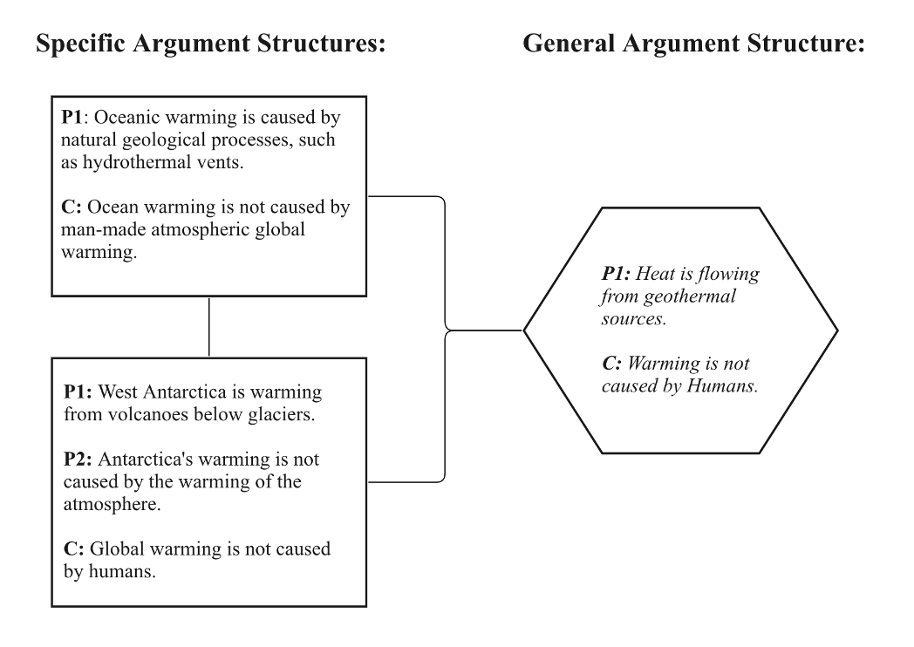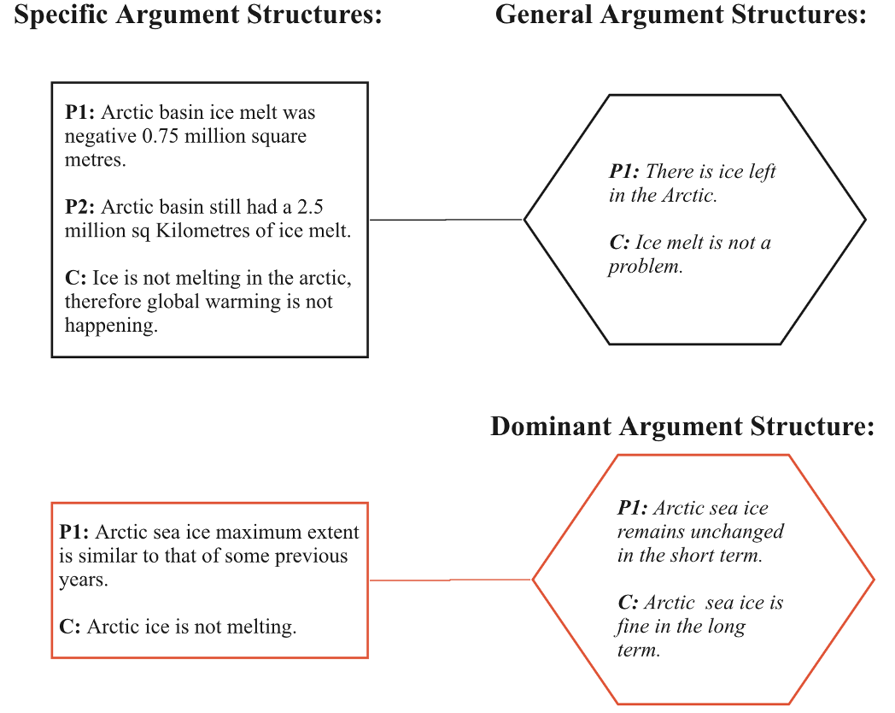

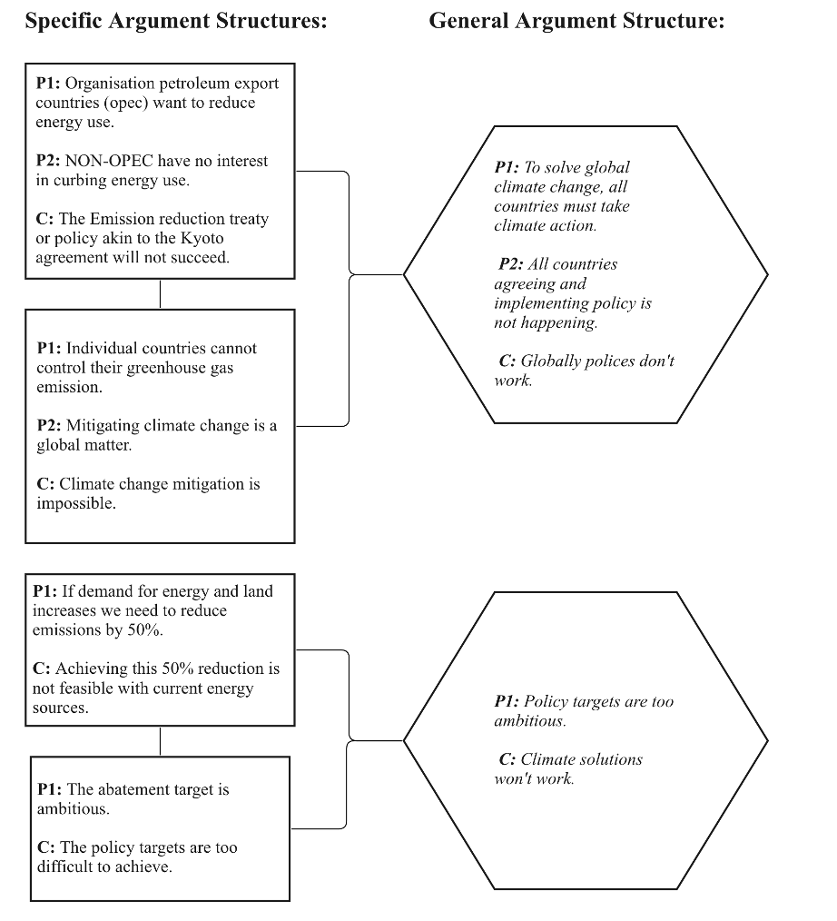

***Notes.*** *a) Example of type 1 deconstruction - homogenous argument (“CO2 lags climate”, 2.3.3). b) Example of type 2 deconstruction - single general argument (claim “It’s geological”, 2.1.2). c) Example of type 3 deconstruction - dominant argument (claim “The Arctic isn’t melting”, 1.1.2)p. The dominant argument structure (red border) is considered to be the “general argument” as it is the argument structure that occurred more than once in the analysed paragraphs and data set. d) Claim “Policy is too difficult” (4.3.1) is an example of Type four deconstruction. No dominant argument is found, however, one argument structure may be recategorised to another claim within the taxonomy.*

Once a general argument structure was finalised for each claim, we moved onto the final step of the deconstruction process—scrutinising each premise in order to identify reasoning fallacies. We used the FLICC framework, featuring a comprehensive list of rhetorical techniques and logical fallacies, to identify reasoning fallacies in the premises (Cook, 2020). Figure 3 visualises our methodology, including a simplified version of the Cook et al. (2018) deconstruction process (steps 1-5).

We deconstructed each claim in the Coan et al. (2018) taxonomy except for the five top level categories (super-claims). While there was conceptual overlap between second-level claims (sub-claims) and third-level claims (sub-sub-claims), it was necessary to deconstruct both levels due to misinformation detection considerations. A sub-claim such as “ice is melting” (1.1) was typically expressed in the form of sub-sub-claims such as “Antarctica isn’t melting” (1.1.1) or “Arctic sea ice isn’t melting” (1.1.3). However, real-world misinformation could be expressed generally without mentioning the sub-sub-claims. Deconstructing these generalised sub-claims was necessary for real-world applications where sub-claims are detected and require a corrective response.

## Figure 3

*Flow chart for deconstructing claims from a dataset of exemplar paragraphs*

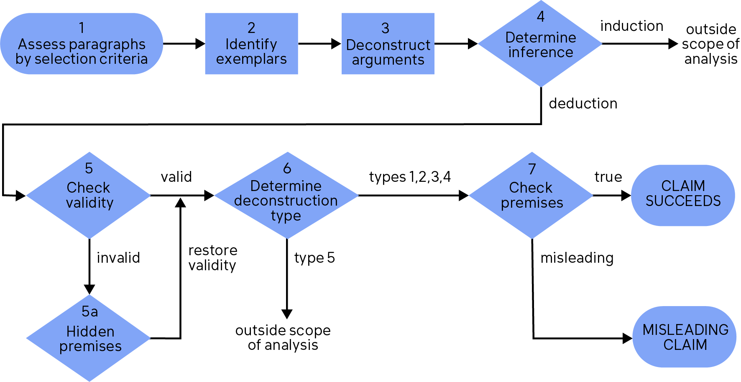

Figure 4 offers conceptual clarity between different fallacies. Cherry picking involves actively focusing on select pieces of evidence while ignoring the bulk of evidence that paints a contrary picture (e.g., “some glaciers are growing”). Slothful induction is a cousin to cherry picking but the emphasis is on focusing on a purported lack of evidence. An explicit example of this is “there’s no evidence for climate change so the science isn’t settled” (5.1.1). A more subtle example is “if impacts aren’t bad yet, they’ll stay that way” where conclusions are made about the future while ignoring any science specifying how conditions will charge in the future.

Conceptually, oversimplification may seem similar to cherry picking as both involve failing to take into account the full picture. The difference between the two is the type of information being ignored. In the case of cherry picking, the type of information is scientific evidence while with oversimplification, it is scientific models. For example, arguing that human CO2 emissions are tiny compared to natural CO2 emissions ignores that natural emissions are matched by natural absorptions (2.1.5). The argument ignores one aspect of the scientific model of the carbon cycle.

Another fallacy targeting scientific models is misrepresentation. Conceptually, misrepresentation and oversimplification are quite distinct. Oversimplification typically makes true statements about a narrow aspect of a scientific model that nevertheless paints a misleading picture because it ignores other aspects of the model. It is true that human CO2 emissions are tiny compared to natural CO2 emissions but a more appropriate comparison is with *net* natural CO2 emissions, taking into account natural absorptions. Misrepresentation typically makes false statements about part of a scientific model. The misleading nature is not due to the omission of relevant details but the active distortion of the scientific model. For example, claiming that water vapor has a stronger warming effect than CO2 is assuming that water vapor has a forcing effect (e.g., drives climate) when in actuality, it has a feedback effect (e.g., responds to climate).

Misrepresentation of scientific models is a close cousin to the straw man fallacy but the two are distinct from each other in structure and intent. The intent of a straw man argument is to falsify an opponent’s position by rephrasing it in weaker form. For example, the IPCC conclusion “we have 12 years to halve CO2 emissions in order to avoid dangerous climate change” was distorted into “alarmists say the world will end in 12 years.” Scientific misrepresentations are structured differently, where one scientific concept is misrepresented and presented as a true statement in order to cast doubt on another concept. For example, the claim “water vapor is the strongest greenhouse gas” misrepresents the nature of water vapor’s greenhouse effect but the intent of the argument is to cast doubt on the significance of CO2 warming.

As misrepresentation involves false statements about scientific models, it is to be distinguished from oversimplification, which is paltering applied to scientific models. It involves what are essentially true statements about one aspect of a scientific model while ignoring other parts of the model, to mislead effect. For example, the claim “human CO2 emissions are tiny compared to natural emissions” is true but misleading as it ignores that natural emissions are matched by natural absorptions.

Figure 4

Conceptual distinctions between different fallacies.

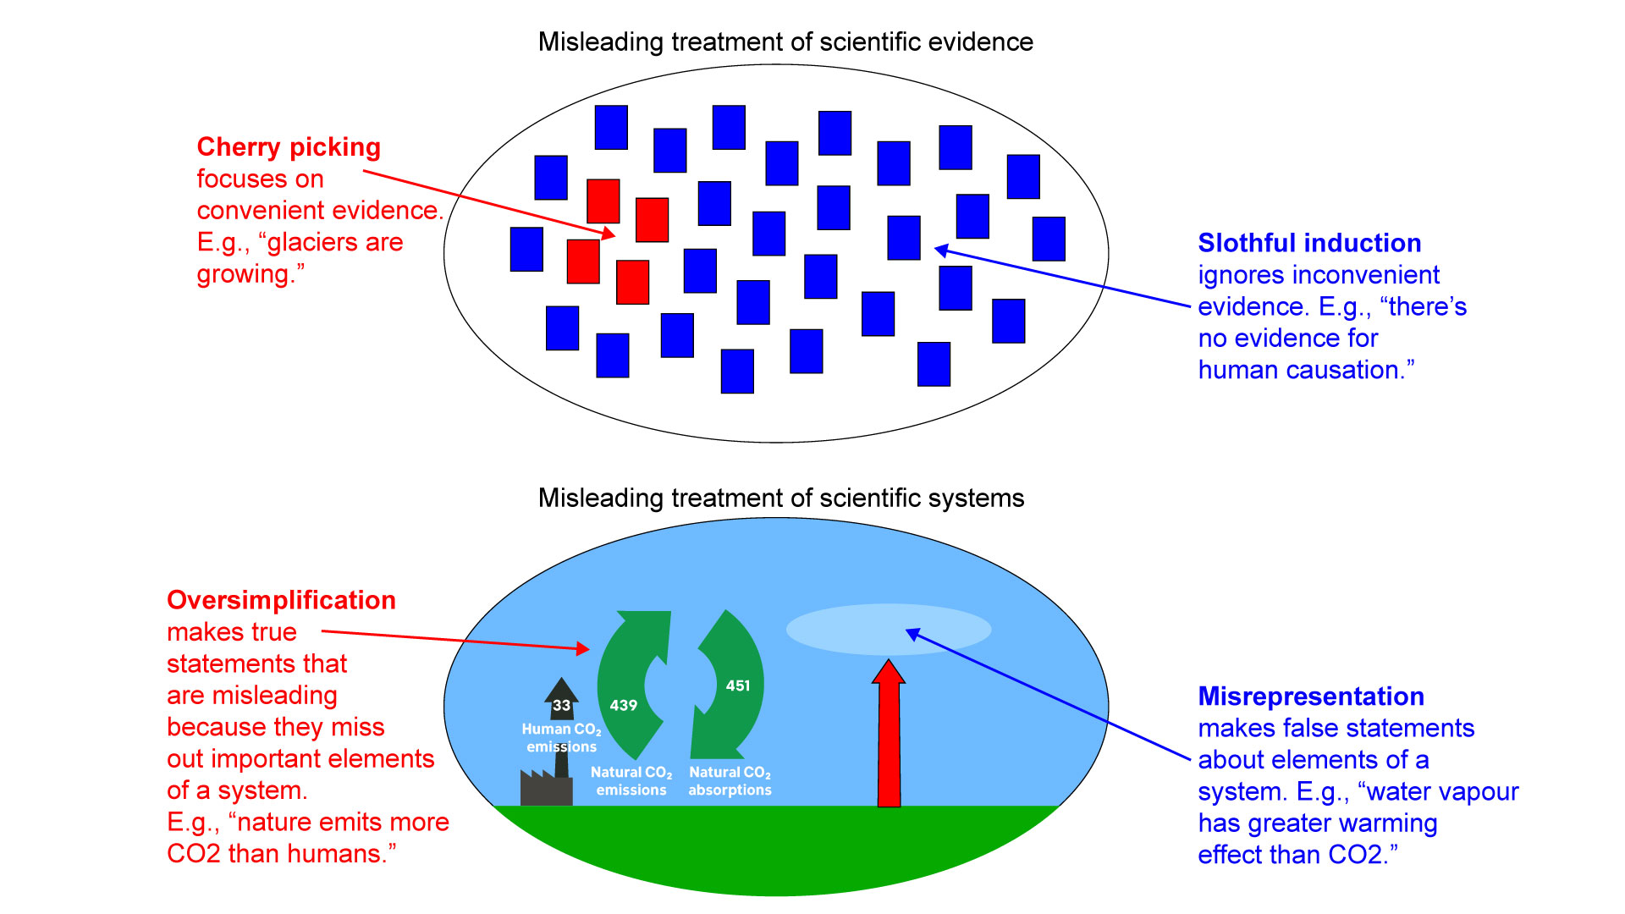

# 3. Results

Table 2 summarises the key results of our deconstruction of the claims in the Coan et al. (2021) taxonomy (for more thorough documentation, see Table S2 in Supplemental Material). Five of the claims supplied insufficient example paragraphs and were excluded from the analysis so that our final analysis involved 71 claims. The most common deconstruction type (XXX%) was type 2 (common argument structure) while the second most common deconstruction type (XXX%) was type 3 (dominant argument structure).

XXX of the XXX claims contained reasoning fallacies and were characterised as misleading. Thus we were successful in extending the work of Coan et al. (2018) by assessing the veracity (or lack thereof) of the contrarian claims in their taxonomy. XXX% of the claims contained multiple fallacies, with the average number of fallacies per claim being XXX.

## Table 2

*Summary of deconstruction of contrarian claims*

| Claim | Type | Argument structure | Hidden premise | Fallacies |
| --- | --- | --- | --- | --- |
| 1.1.1. Antarctica is melting | 2 | P1: Antarctica is cooling.  P2: Sea ice is increasing.  C: Global warming is not happening | P3: Cooling is the only driver of sea ice gain therefore global warming is not happening | P2: Slothful induction  P3: Impossible expectations  P4: Single cause |
| 1.1.2. Greenland isn't melting. | 2 | P1: Parts of Greenland's ice sheet are not melting.  C: Global warming is not happening. | P2: All parts of ice sheets must be melting under global warming. | P1: Cherry picking  P2: Single cause, Impossible expectations |
| 1.1.3. Arctic isn’t melting | 3 | P1: In the short term, Arctic sea ice hasn't changed much.  C: Arctic sea ice is fine. | P2: If Arctic sea ice maximum extent hasn't changed much in the short-term, then Arctic sea ice is fine in the long-term. | P2: Cherry picking |
| 1.1.4. Glaciers aren’t melting | 3 | P1: Glaciers are growing in some regions  C: Glaciers are fine. | P2: If glaciers are growing anywhere in the world, then glaciers must be fine. | P2: Cherry picking,  Oversimplification |
| 1.2 Heading into an ice age | 2 | P1: Current climate change is driven by natural factors.  P2: Natural factors are currently having a cooling effect.  C: If natural cooling continues, we will experience more cooling in the future. | P3: Greenhouse gases don't have much warming effect. | P1: Cherry picking,  Slothful induction  P3: Misrepresentation |
| 1.3 Weather is cold | 2 | P1: Cold weather events are occuring.  C: Global warming is not happening. | P2: If global warming was happening, we wouldn't experience cold events. | P1: Anecdote  P2: Impossible expectations |
| 1.4 Hiatus on warming | 3 | P1: There's been no warming over a short period.  C: Global warming is not happening. | P2: Short time periods are sufficient to make conclusions about climate trends. | P1: Cherry picking, Slothful induction  P2  Misrepresentation, Cherry picking |
| 1.6 Sea level rise is exaggerated | 2 | P1: Sea levels within a specific time period or region have not shown dramatic increase.  C: Sea level rise is exaggerated. | P2: Results from a narrow set of sea level rise data can be generalized more broadly.  P3: Regional factors like subsidence are not a factor in sea level measurements. | P1: Cherry picking  P2: Slothful induction  P3: Oversimplification |
| 1.7 Extremes aren't increasing | 3 | P1: Extreme weather happened in the past before recent global warming.  C: Global warming is not linked to extreme weather. | P2: If global warming didn't affect past extreme weather, they mustn't be affecting current extreme weather either.  P3: The frequency or intensity of extreme weather isn't getting worse. | P2: Single cause  P3: Cherry picking |
| 2.1.1. It's the sun | 3 | P1: There is a link between solar activity and climate.  C: Recent climate change is caused by the sun. | P2: If the sun can affect climate, it must be affecting current climate change. | P1: Slothful induction  P2: Single cause |
| 2.1.2. It’s geological | 2 | P1: Heat is flowing from geothermal sources.  C: Warming is not caused by Humans. | P2: Natural geological process is the only cause of warming. | P2: Single cause, Slothful induction |
| 2.1.3. Its the ocean | 2 | P1: Ocean cycles influence global temperature.  C: Ocean cycles are causing global warming. | P2: If ocean cycles affect global temperatures in the short term it then they must affect it in the long term. | P2  Single cause, False equivalence |
| 2.1.4. Past climate change | 3 | P1: Climate has changed due to natural causes in the Earth's past.  P2: Climate is changing now.  C: Current climate change must be natural. | P3: Current climate change is similar to past climate change.  P4: What caused climate change in the past must be the same as what's causing climate change now. | P3: False equivalence  P4: Single cause |
| 2.3.1. CO2 is a trace gas | 2 | P1: CO2 is a trace gas, it makes up only a small component of the atmosphere.  C: CO2 cannot be the main cause of global warming. | P2: If there is a smaller quantity of CO2, its warming potential is also less. | P2: Misrepresentation |
| 2.3.2. Greenhouse effect is saturated | 1 | P1: CO2 has a diminishing warming effect with higher concentrations.  C: Adding more CO2 to the atmosphere will have a negligible impact on warming. | P2: CO2 is saturated in all levels of the atmosphere. | P2: Oversimplification |
| 2.3.3. CO2 lags climate | 1 | P1: CO2 lagged temperature in the past.  C: CO2 does not drive temperature. | P2: If temperature affects CO2, then CO2 cannot affect temperature. | P1: Slothful induction  P2: False choice |
| 2.3.4. Water vapour | 2 | P1: Water vapour is more heat-trapping or plentiful than CO2.  C: Water vapour contributes more to global warming than CO2. | P2: The warming of a greenhouse gas depends on quantity or heat-trapping ability. | P2: Misrepresentation |
| 2.3.5. Tropospheric hot spot | 2 | P1: Greenhouse warming should cause a tropospheric hot spot over the tropics.  P2: The hot spot hasn't been observed.  C: Global warming is not caused by greenhouse gases. | P3: If there's a discrepancy between models and observations, the models must be wrong.  P4: The hot spot is a unique fingerprint of greenhouse warming. | P2: Slothful induction  P3: Misrepresentation  P4: Misrepresentation |
| 3.1 Sensitivity is low |  |  |  |  |
| 3.2.1. Species can adapt | 2 | P1: Species have shown resilience to climate change either now or in the past.  C: Species can adapt to climate change. | P2: Species have been resilient to date so they will continue to be resilient in the future. | P1: Cherry picking  P2: Slothful induction, False equivalence |
| 3.2.2. Polar bears are ok | 3 | P2: Polar bear populations are increasing in some regions.  C: Global warming is not harming polar bear populations. | P2: Polar bear populations cannot be increasing anywhere under global warming. | P1: Cherry picking  P2: Oversimplification |
| 3.2.3. Oceans are ok | 3 | P1: Coral reefs are resilient against acidification and bleaching.  C: Climate change impacts on coral reefs are not serious. | P2: Acidfication or bleaching alone are the only negative climate change impacts on coral reefs.  P3: If one species shows resilience to climate change, we can assume other species will also be resilient.  P4: Current climate change will be no more harmful than past climate change. | P2: Cherry picking  P3: Oversimplification  P4: Slothful induction |
| 3.3.1. CO2 is plant food | 2 | P1: CO2 is beneficial for plant growth.  C: Emitting more CO2 will be good for plants. | P2: Increased CO2 only has beneficial effects for plants. | P2: Slothful induction, Cherry picking |
| 4.1.1. Policy increases cost | 2 | P1: Climate policy increases energy costs.  P2: Increased energy costs will have harmful effects.  C: Climate policy is harmful. | P3: Fossil fuel use increases quality of life.  P4: The cost of climate action is greater than the cost of climate impacts.  P5: Climate action doesn't have any positive benefits. | P1: Oversimplification  P4: Slothful induction  P5: Oversimplification |
| 4.1.3. Policy harms the environment | 2 | P1: Clean energy has costs on the economy and the environment.  C: Clean energy is harmful. | P2: The negatives of clean energy outweigh the benefits. | P2: Cherry picking |
| 4.1.5. Limits freedoms | 4 | P1: Climate policy limits the choices available to people and communities.  C: Climate policy reduces people's freedom. | P2: Failing to act on climate change will have no impact on people's freedom.  P3: Regulations only have negative impacts on people. | P2: Oversimplification  P3: Cherry picking |
| 4.2.1. Green jobs don't work | 3 | P1: Green jobs are a small proportion of overall jobs and growing slowly.  C: Green jobs won't work. | P2: The growth rate of green jobs will remain the same over time.  P3: Economic factors are all that matter when considering green jobs. | P1: Impossible expectations  P2: Slothful induction  P3: Oversimplification |
| 4.2.3. Policy impact is negligible | 3 | P1: A single policy would have a negligible impact.  C: We should not have the policy. | P2: If a single policy doesn't solve the problem, then it is not worth implementing. | P2: Impossible expectations |
| 4.2.5. Better to adapt | 3 | P1: Climate action reduces wealth.  P2: Wealth increases resilience to climate action.  C: It is better to adapt to climate change than to mitigate it. | P3: Failing to mitigate climate change won't have an impact on our wealth or ability to adapt to climate change. | P1: Cherry picking  P3: Slothful induction |
| 4.2.6. China's emissions | 3 | P1: Developing countries are not doing enough to share the burden of reducing global emissions.  P2: One country cutting emissions will make a negligible difference to global emissions.  C: One country reducing emissions is pointless. | P3: One country shouldn't reduce emissions if their action alone won't reduce global emissions.  P4: All countries are the same so they should be held to the same emsission reduction standards. | P1: Oversimplification  P3: Impossible expectations  P4: Oversimplification |
| 4.3.1. Policy is too difficult | 2 | P1: Solving climate change will be difficult and expensive.  P2: Making the technical transition or getting global agreement will be difficult.  C: Solving climate change is too difficult. | P3: Because emission reduction and political agreement is difficult, it can't be done. | P3: Hasty generalization, Circular reasoning |
| 4.3.2. Low public support | 2 | P1: Much of the public aren't convinced about the need for climate action.  C: Political action on climate change is too hard. | P2: Without public support, climate policy is impossible. | P1: Cherry picking |
| 4.4.1. Clean energy unreliable | 3 | P1: Clean energy has costs on the economy and the environment.  C: Clean energy is harmful. | P2: The negatives of clean energy outweigh the benefits. | P2: Cherry picking |
| 4.5.1. Fossil fuels are plentiful | 2 | P1: There is an abundance of fossil fuel resources.  C: We should keep using fossil fuel. | P2: If we have fossil fuels, we should use them rather than other sources. | P2: Slothful induction |
| 4.5.2. Fossil fuels are cheap | 2 | P1: Fossil fuels are the cheapest form of energy.  C: We should use fossil fuel energy. | P2: Cheaper costs is more important than other factors like climate change impacts. | P1: Slothful induction  P2: Oversimplification |
| 5.1.1. No consensus | 2 | P1: There's not enough evidence to know what's happen with climate.  C: There's no scientifc consensus on climate change. |  | P1: Slothful induction, Impossible expectations |
| 5.1.2. Proxies are unreliable | 1 | P1: Proxy data is affected by non-climate factors and measuring limitations.  C: Climate proxies are unreliable. | P2: Scientists don't know how to adjust for limitations and other factors. | P2: Misrepresentation |
| 5.1.3. Temp is unreliable | 3 | P1: Temperature data is affected by non-climate factors and measuring limitations.  C: The temperature record is unreliable. | P2: Scientists don't know how to adjust for limitations. | P2: Slothful induction, Red Herring |
| 5.1.4. Models are unreliable | 3 | P1: Climate model predictions don't match observations.  C: Climate models are unreliable. | P2: If there's a discrepancy between models and observations, the models must be wrong. | P1: Cherry picking  P2: Oversimplification |
| 5.2.1. Climate is a religion | 2 | P1: The climate change movement have some trait in common with religion.  C: The climate change movement is a religion and unscientific. | P2: A movement that has any traits in common with a religion is a religion. | P2: Misrepresentation  P3: False equivalence |
| 5.2.2. Media is alarmist | 3 | P1: Media portrayal of climate change supports the mainstream view.  C: The media are biased and cannot be trusted. | P2: If the media supports the mainstream view on climate change, they must be biased. | P2: Ad hominem, Misrepresentation |
| 5.2.3. Politicians are biased | 2 | P1: Governments and politicians support the mainstream view on climate change.  C: Governments are biased and untrustworthy. | P2: If governments or politicians support the mainstream view on climate change, they must be biased. | P2: Ad hominem, Misrepresentation |
| 5.2.4. Environmentalists are biased | 2 | P1: Environmentalists get science wrong as they're not committed to science.  C: Environmentalists are biased and unreliable. |  | P1: Ad hominem |
| 5.2.5. Scientists are biased | 2 | P1: Scientists act in biased or unethical ways.  C: Scientists and their science can't be trusted |  | P1: Ad hominem |
| 5.3.1. Policy is a conspiracy | 2 | P1: Governing bodies and corporations act secretly on climate policy.  C: Climate policy is part of a conspiracy. | P2: Secret actions by governing bodies and corporations must be for nefarious motives. | P1: Conspiracy theory  P2: Conspiracy theory |
| 5.3.2. Science is a conspiracy | 2 | P1: Scientists have commited a range of conspiratorial actions to defend the mainstream view and suppress dissenting views.  C: There is a conspiracy among scientists to deceive the public. |  | P1: Conspiracy theory |

*Note.* Table 1 includes the deconstruction type, general/dominant argument structure, hidden premise/s, and reasoning fallacies of each contrarian claim. Grey sections denote climate science misinformation (categories 1,2,3 and 5 of the taxonomy) while yellow denotes climate solutions misinformation (category 4). For deconstruction types 3 and 4 the bolded text highlighted the prominent general argument/dominant argument structure for a sub-sub-claim.

ANALYSE MOST COMMON FALLACIES.

Almost every claim was judged logically invalid and required the addition of a hidden premise. Among the invalid claims, every hidden premise contained reasoning fallacies. Only XXX claims were considered logically valid. All of these claims contained the ad hominem fallacy.

# 4. Discussion

Understanding how climate change misinformation misleads is a crucial step to neutralising its negative influence. This study set out to identify the breadth of reasoning fallacies employed in a comprehensive taxonomy of contrarian climate claims. We developed a methodology to deconstruct real-world misinformation exemplars. A novel addition was the development of deconstruction types, offering a systematic method of identifying the most representative argument structure for each contrarian claim.

We identified cherry picking and oversimplification as the most commonly employed fallacies. Both of these techniques were often found in the same claim, with XXX% of claims employing cherry picking in one premise and oversimplification in the other. For example, in the claim “CO2 is plant food” (3.3.1), the first premise employed oversimplification, while the second premise used slothful induction. Furthermore, some single premises contained two fallacies. In the claim “policy is a conspiracy” (5.3.1), the premise “decision making authorities should always be 100% transparent or otherwise they can't be trusted” utilised both ad hominem and impossible expectations.

Comparing this study's findings to prior work on deconstructing climate denialist claims helps to validate the methodology. Cook et al. (2018) is the only comparable study, although it restricted its scope to climate science misinformation found in categories 1 to 3 in the Coan et al. (2021) taxonomy. In most cases, our identified fallacies matched the fallacies identified in Cook et al. (2018). However, there were two noticeable discrepancies between the two studies. The first was the claim “species can adapt” (3.2.1), where Cook et al. (2018) identified the use of misrepresentation, while we identified cherry picking and oversimplification. For the claim “environmentalists are alarmists” (5.2.4), Cook et al. (2018) identified cherry picking while we found ad hominem and slippery slope. Contributing factors to this discrepancy could be differences in how the argument was represented and the subjective nature of critical thinking work.

Among the 71 claims analysed, 68 contained hidden premises and in all cases, a hidden premise contained reasoning fallacies. Assessing which reasoning fallacy played the greatest role in making the argument misleading is beyond the scope of this study. Nevertheless the fact that XX of misleading contrarian climate claims contained hidden premises with reasoning fallacies supports the intuition that unstated assumptions should be uncovered to fully understand why an argument is misleading. It also reinforces the value of a critical-thinking-based approach which offers a systematic method of “logic-checking” claims with hidden premises.

The process of deconstructing a diverse range of contrarian claims also added nuance to past critical thinking work. The *impossible expectations* fallacy was previously defined as “demanding unrealistic standards of certainty before acting on the science” (Cook, 2022). This definition was suitable for science-based claims such as “models are unreliable” (5.1.4). However, impossible expectations was also found in the solutions-based claim “policy has a negligible impact” (4.2.3) which argued that if a single policy did not fix the problem, it was not worth implementing. This claim unrealistically demands that a single policy must comprehensively solve climate change in order to be implemented (equivalent to arguing “the first step won’t get me out of the way of oncoming traffic so I might as well not move“). Applying impossible expectation to a policy context demonstrated the limitation of the existing definition of impossible expectations. Consequently, we broadened the definition for impossible expectation so that it was applicable in a wider range of contexts (Table S1, see also http://sks.to/flicc).

Claims that were logically valid without the need to add a hidden premise all contained the ad hominem fallacy, involving a character attack on a person or group who accept the reality of climate change and/or the need for climate action. This is not to say that all ad hominem attacks are necessarily valid arguments (Walton, 1998). An ad hominem attacking a person’s trait (e.g., “Al Gore is fat”) might be irrelevant to the conclusion disregarding the person’s argument (e.g., “therefore Al Gore’s film is not credible “) and therefore logically invalid. In the ad hominem claims in our analysis, the premises (e.g., “scientists act in a biased or unethical way”) were relevant to the conclusion (e.g., “therefore scientists are unreliable “) and hence were deemed logically valid. In all the exemplars we examined, the premise accusing a target of being biased or unethical was judged to be false. Nevertheless, a limitation of our approach is that we cannot state definitively that in every instance, members of the climate movement are unbiased and ethical. Our approach to this kind of argument was to explain in general terms how ad hominem arguments focus on a person’s character in order to distract from their arguments.

Another limitation of our study was the coverage of the training data used to harvest exemplars representing each contrarian claim. There was much variance in the quantity of paragraphs matching each claim, ranging from 0 to 766 paragraphs per claim with 17 claims having less than 20 paragraphs and one claim having zero examples. We considered the number of example paragraphs a proxy for the prominence of each claim so concluded that excluding low-represented claims was appropriate. While obtaining more exemplar paragraphs was outside the scope of this study, future research could expand the training dataset with an emphasis on building underrepresented claims.

Limited resources were available for the deconstruction process so greater resources would facilitate a more detailed analysis. We sampled approximately 20 example paragraphs for each claim in order to identify a general argument structure representing the contrarian claim. Sampling a larger number of paragraphs would likely result in identification of more argument structures, which would provide a more comprehensive (albeit complicated) summary of fallacies. A more thorough treatment would enable distinguishing between factual statements such as “the weather was cold somewhere on a certain day” and misleading statements such as “the weather is cold today, therefore global warming is not happening” (1.3). Although every claim we deconstructed could be represented by a single argument structure, it is likely that there are further argument structures that are not captured by our current analysis. This would lead to expansion of the taxonomy to include new contrarian claims which would in turn necessitate further training of any machine learning model used to detect claims.

The fact that contrarian claims contain multiple fallacies has communication consequences. Will explaining more than one fallacy be more or less effective than explaining a single fallacy in a correction message? If a correction was to include just a single fallacy explanation (e.g., due to space or attention constraints), how would one choose one fallacy among several in order to maximize the effectiveness of a correction? Future research into logic-based corrections should consider these questions when experimentally testing correction formats.

While our research yields theoretical insights that stand on their own, this work was designed to be implemented within broader, holistic frameworks such as the 4D framework, which involves *detecting* misinformation claims, *deconstructing* the claims to identify reasoning fallacies, *debunking* the misinformation with logic-based corrections, and at-scale solutions (Cook, 2022). Our work seamlessly fits within this framework, hence the close interface between the detection research in Coan et al. (2021) and our output lending itself to logic-based corrections (Kim et al., XXXX; Vraga et al., XXXX).

This study sought to deconstruct a comprehensive taxonomy of contrarian climate claims, identifying reasoning fallacies and misleading claims. In the process, we expanded the critical thinking deconstruction methodology developed in Cook et al. (2018). Our work is to date the most comprehensive effort to deconstruct contrarian claims about climate change, incorporating both climate science and solutions misinformation. It provides a foundation for future work on deconstruction and a generalisable methodology that could be applied in a variety of technical applications and other topics that are afflicted by misinformation.

# 5. References

Abbass, K., Qasim, M. Z., Song, H., Murshed, M., Mahmood, H., & Younis, I. (2022). A review of the global climate change impacts, adaptation, and sustainable mitigation measures. *Environmental Science and Pollution Research*, *29*(28), 42539–42559. https://doi.org/10.1007/s11356-022-19718-6

Adair, B. (2011, July 27). A Change in the Meter: Barely True Is Now Mostly False. PolitiFact. Retrieved from https://www.politifact.com/article/2011/jul/27/-barely-true-mostly-false/

Al-Rawi, A., OʼKeefe, D., Kane, O., & Bizimana, A.-J. (2021). Twitter’s Fake News Discourses Around Climate Change and Global Warming. *Frontiers in Communication*, *6*.

Bonds, E. (2016). Beyond denialism: think tank approaches to climate change. *Sociology Compass*, *10*(4), 306-317.

Boussalis, C., & Coan, T. G. (2016). Text-mining the signals of climate change doubt. *Global Environmental Change*, *36*, 89–100. https://doi.org/10.1016/j.gloenvcha.2015.12.001

Capstick, S. B., & Pidgeon, N. F. (2014). What is climate change scepticism? Examination of the concept using a mixed methods study of the UK public. *Global Environmental Change*, *24*, 389-401.

Chapman, G., & Python, M. (Eds.). (1989). *The Complete Monty Python's Flying Circus: All the Words. Volume One* (Vol. 1). Pantheon.

Coan, T. G., Boussalis, C., Cook, J., & Nanko, M. O. (2021). Computer-assisted classification of contrarian claims about climate change. *Scientific Reports*, *11*(1), 22320. https://doi.org/10.1038/s41598-021-01714-4

​​Cook, J. (2019). Understanding and countering misinformation about climate change. *In Chiluwa, I. & Samoilenko, S. (Eds.), Handbook of Research on Deception, Fake News, and Misinformation Online*.

​​Cook, J. (2020). Deconstructing Climate Science Denial. In Holmes, D. & Richardson, L. M. (Eds.) *Edward Elgar Research Handbook in Communicating Climate Change*. Cheltenham: Edward Elgar.

Cook, J. (2022). *The 4D framework: a holistic approach to countering climate change misinformation*. Companion to Development Studies. Routledge.

Cook, J., Ellerton, P., & Kinkead, D. (2018). Deconstructing climate misinformation to identify reasoning errors. *Environmental Research Letters*, *13*(2), 024018. https://doi.org/10.1088/1748-9326/aaa49f

Cook, J., Lewandowsky, S., & Ecker, U. K. H. (2017). Neutralizing misinformation through inoculation: Exposing misleading argumentation techniques reduces their influence. *PLOS ONE*, *12*(5), e0175799. https://doi.org/10.1371/journal.pone.0175799

Cook, J., Oreskes, N., Doran, P. T., Anderegg, W. R. L., Verheggen, B., Maibach, E. W., Carlton, J.S., Lewandowsky, S., Green, S. A., Skuce, A. G., Nuccitelli, D., Jacobs, P., Richardson, M., Winkler, B., Painting, R., Rice, K. (2016). Consensus on consensus: a synthesis of consensus estimates on human-caused global warming. *Environmental Research Letters*, *11*(4), 048002.

Diethelm, P., & McKee, M. (2009). Denialism: what is it and how should scientists respond? *The European Journal of Public Health*, *19*(1), 2-4.

Feulner, G., & Rahmstorf, S. (2010). On the effect of a new grand minimum of solar activity on the future climate on Earth. *Geophysical Research Letters*, *37*(5).

Gasper, R., Blohm, A., & Ruth, M. (2011). Social and economic impacts of climate change on the urban environment. *Current Opinion in Environmental Sustainability*, *3*(3), 150–157. https://doi.org/10.1016/j.cosust.2010.12.009

Geiger, N., & Swim, J. K. (2016). Climate of silence: Pluralistic ignorance as a barrier to climate change discussion. *Journal of Environmental Psychology*, *47*, 79-90.

Graves, L. (2013). Deciding what's true: Fact-checking journalism and the new ecology of news. Columbia University.

Graves, D. (2019). Understanding the promise and limits of automated fact-checking. *Reuters Institute for the Study of Journalism*. https://ora.ox.ac.uk/objects/uuid:f321ff43-05f0-4430-b978-f5f517b73b9b

Hassan, N., Adair, B., Hamilton, J. T., Li, C., Tremayne, M., Yang, J., & Yu, C. (2015, July). The quest to automate fact-checking. In *Proceedings of the 2015 Computation+ Journalism symposium*.

Jacobson, R. M., Targonski, P. V., & Poland, G. A. (2007). A taxonomy of reasoning flaws in the anti-vaccine movement. *Vaccine*, *25*(16), 3146-3152.

Lamb, W. F., Mattioli, G., Levi, S., Roberts, J. T., Capstick, S., Creutzig, F., Minx, J. C., Müller-Hansen, F., Culhane, T., & Steinberger, J. K. (2020). Discourses of climate delay. *Global Sustainability*, *3*. https://doi.org/10.1017/sus.2020.13

Leiserowitz et al., 2021

Lewandowsky, S., Ballard, T., Oberauer, K., & Benestad, R. (2016). A blind expert test of contrarian claims about climate data. *Global Environmental Change*, *39*, 91-97.

Lewandowsky, S., Ecker, U. K. H., & Cook, J. (2017). Beyond Misinformation: Understanding and Coping with the “Post-Truth” Era. *Journal of Applied Research in Memory and Cognition*, *6*(4), 353–369. https://doi.org/10.1016/j.jarmac.2017.07.008

Lewandowsky, S., Oreskes, N., Risbey, J. S., Newell, B. R., & Smithson, M. (2015b). Seepage: Climate change denial and its effect on the scientific community. *Global Environmental Change*, *33*, 1-13.

Lim, C. (2018). Checking how fact-checkers check. *Research & Politics*, *5*(3), 2053168018786848.

McCright, A. M., Charters, M., Dentzman, K., & Dietz, T. (2016). Examining the effectiveness of climate change frames in the face of a climate change denial counter-frame. *Topics in cognitive science*, *8*(1), 76-97.

McCright, A. M., & Dunlap, R. E. (2011). The politicization of climate change and polarization in the American public's views of global warming, 2001–2010. *The Sociological Quarterly*, *52*(2), 155-194.

McGuire, W. J., & Papageorgis, D. (1961). The relative efficacy of various types of prior belief-defense in producing immunity against persuasion. *Public Opinion Quarterly*, *26*, 24-34.

Myers, K. F., Doran, P. T., Cook, J., Kotcher, J., & Myers, T. A. (2021). Consensus revisited: quantifying scientific agreement on climate change and climate expertise among Earth scientists 10 years later, *Environmental Research Letters*, *16*(10), 104030.

Nieminen, S., & Sankari, V. (2021). Checking PolitiFact’s Fact-Checks. *Journalism Studies*, *22*(3), 358-378.

Nyhan, B., & Reifler, J. (2015). The Effect of Fact-Checking on Elites: A Field Experiment on U.S. State Legislators: THE EFFECT OF FACT-CHECKING ON ELITES. *American Journal of Political Science*, *59*(3), 628–640. https://doi.org/10.1111/ajps.12162

Rahmstorf, S. (2004). The climate sceptics. In *Weather Catastrophes and Climate Change—Is There Still Hope For Us?* (76-83), Munich Re.

Ranney, M.A. & Clark, D. (2016). Climate Change Conceptual Change: Scientific Information Can Transform Attitudes. *Topics in Cognitive Science*, *8*(1), 49-75.

Rogers, T., Zeckhauser, R., Gino, F., Norton, M. I., & Schweitzer, M. E. (2017). Artful paltering: The risks and rewards of using truthful statements to mislead others. *Journal of Personality and Social Psychology*, *112*(3), 456.

Samoilenko, S. A. & Cook, J. (2022). Developing an Ad Hominem Typology for Classifying Climate Misinformation.

Schmid, P., & Betsch, C. (2019). Effective strategies for rebutting science denialism in public discussions. *Nature Human Behaviour*, *3*(9), 931–939. https://doi.org/10.1038/s41562-019-0632-4

Socolow, R. H., & Glaser, A. (2009). Balancing risk: nuclear energy & climate change. *Daedalus*, *138*(4), 31-44.

Stecula, D. A., & Merkley, E. (2019). Framing climate change: Economics, ideology, and uncertainty in American news media content from 1988 to 2014. *Frontiers in Communication*, *4*, 6.

Treen, K. M. d’I., Williams, H. T. P., & O’Neill, S. J. (2020). Online misinformation about climate change. *WIREs Climate Change*, *11*(5). https://doi.org/10.1002/wcc.665

van der Linden, S., Leiserowitz, A., Rosenthal, S., & Maibach, E. (2017). Inoculating the Public against Misinformation about Climate Change. *Global Challenges*, *1*(2), 1600008.

Walton, D. (1998). *Ad hominem arguments.* Tuscaloosa, AL: University of Alabama Press.

Zhou, X., & Zafarani, R. (2020). A Survey of Fake News: Fundamental Theories, Detection Methods, and Opportunities. *ACM Computing Surveys*, *53*(5), 109:1–109:40. https://doi.org/10.1145/3395046

# 

# 6. Supplementary Material

## S1. Fallacies

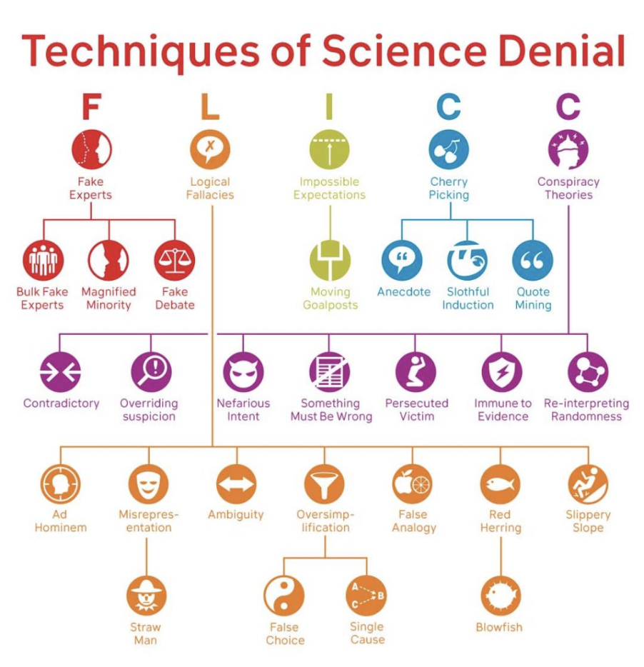

*Figure S1: Fake experts Logical fallacies Impossible expectations Cherry picking and Conspiracy theories (FLICC) taxonomy presents a comprehensive list of techniques/fallacies used to deny science. The FLICC taxonomy is generalisable to climate science and climate solutions misinformation (Cook, 2020).*

## Table S1: Fallacy definitions adapted from Cook (2020).

| **TECHNIQUE** | **DEFINITION** |
| --- | --- |
| Ad Hominem | Attacking a person/group instead of addressing their arguments. |
| Ambiguity | Using ambiguous language in order to lead to a misleading conclusion. |
| Anchoring | Depending too heavily on an initial piece of information when making subsequent judgments. |
| Anecdote | Using personal experience or isolated examples instead of sound arguments or compelling evidence. |
| Blowfish | Focusing on an inconsequential aspect of scientific research, blowing it out of proportion in order to distract from or cast doubt on the main conclusions of the research. |
| Bulk Fake Experts | Citing large numbers of seeming experts to argue that there is no scientific consensus on a topic. |
| Cherry Picking | Carefully selecting data that appear to confirm one position while ignoring other data that contradicts that position. Emphasis is on a lack of confirming evidence rather than on ignoring disconfirming evidence. |
| Contradictory | Simultaneously believing in ideas that are mutually contradictory. |
| Conspiracy Theory | Proposing that a secret plan exists to implement a nefarious scheme such as hiding a truth. |
| Fake Debate | Presenting science and pseudoscience in an adversarial format to give the false impression of an ongoing scientific debate. |
| Fake Experts  *(appeal to false authority)* | Presenting an unqualified person or institution as a source of credible information. |
| False Analogy | Assuming that because two things are alike in some ways, they are alike in some other respect. |
| False Balance | Inappropriately presenting two things as equal. *(fake debate is an example of false balance)* |
| False Choice  *(false dichotomy, either/or)* | Presenting two options as the only possibilities, when other possibilities exist. |
| False Equivalence  *(apples vs. oranges)* | Incorrectly claiming that two things are equivalent, despite the fact that there are notable differences between them. |
| Immune to evidence | Re-interpreting any evidence that counters a conspiracy theory as originating from the conspiracy. |
| Impossible Expectations | Demanding unrealistic standards of certainty before acting on the science. For scientific arguments, this applies to standards of proof. For policy, it applies to effectiveness of policies. For environmental arguments, this applies to expectations of physical reality. |
| Logical Fallacies | Arguments where the conclusion does not logically follow from the premises. Also known as a non sequitur. |
| Lowered Expectations | Lowering the standard by which you grade a performance or assess evidence. |
| Magnified Minority | Magnifying the significance of a handful of dissenting scientists to cast doubt on an overwhelming scientific consensus. |
| Misrepresentation | Misrepresenting a situation or an opponent’s position in such a way as to distort understanding. Differs from oversimplification which can represent part of a system accurately (but omit important details in a misleading way) whereas misrepresentation represents part of a system falsely. |
| Moving Goalposts | Demanding higher levels of evidence after receiving requested evidence. |
| Nefarious intent | Assuming that the motivations behind any presumed conspiracy are nefarious. |
| Overriding suspicion | Having a nihilistic degree of skepticism towards the official account, preventing belief in anything that doesn’t fit into the conspiracy theory. |
| Oversimplification | Simplifying a situation in such a way as to distort understanding, leading to erroneous conclusions. Differs from cherry picking in that oversimplification focuses on an aspect of a system while cherry picking focuses on an aspect of a body of evidence. |
| Persecuted victim | Perceiving and presenting themselves as the victim of organized persecution. |
| Quote Mining | Taking a person’s words out-of-context in order to misrepresent their position. |
| Re-interpreting randomness | Believing that nothing occurs by accident, so that random events are re-interpreted as being caused by the conspiracy. |
| Red Herring | Deliberately diverting attention to an irrelevant point to distract from a more important point. |
| Single Cause | Assuming a single cause or reason when there might be multiple causes or reasons. |
| Slippery Slope | Suggesting that taking a minor action will inevitably lead to major consequences. |
| Slothful Induction | Ignoring relevant evidence when coming to a conclusion. Emphasis is on a lack of disconfirming evidence rather than on cherry picked confirming evidence. |
| Something must be wrong | Maintaining that “something must be wrong” and the official account is based on deception, even when specific parts of a conspiracy theory become untenable. |
| Straw Man | Misrepresenting or exaggerating an opponent’s position to make it easier to attack. |
| Wishful Thinking | Choosing to believe something is true because we really want it to be true, instead of relying on scientific evidence. |

## 

## Table S2: Progress

Paragraph quantity and status of each contrarian “childless claim” in the Coan et al. (2021) taxonomy

| **Claim No.** | **Claim** | **Paragraph Qty** | **Status** |
| --- | --- | --- | --- |
| 1.1.1 | Antarctica isn’t melting | 143 | Deconstructed |
| 1.1.2 | Greenland isn't melting. | 19 | Deconstructed |
| 1.1.3 | Arctic isn’t melting | 129 | Deconstructed |
| 1.1.4 | Glaciers aren’t melting | 25 | Deconstructed |
| 1.2 | Heading into ice age | 147 | Deconstructed |
| 1.3 | Weather is cold | 229 | Deconstructed |
| 1.4 | Hiatus in warming | 483 | Deconstructed |
| 1.5 | Oceans are cooling | 0 | No data |
| 1.6 | Sea level rise is exaggerated | 189 | Deconstructed |
| 1.7 | Extremes aren’t increasing | 427 | Deconstructed |
| 1.8 | Changed the name | 0 | No data |
| 2.1.1 | It's the sun | 247 | Deconstructed |
| 2.1.2 | It’s geological | 16 | Deconstructed |
| 2.1.3 | Its the ocean | 88 | Deconstructed |
| 2.1.4 | Past climate change | 433 | Deconstructed |
| 2.1.5 | Tiny CO2 emissions | 0 | No data |
| 2.2 | Non-greenhouse gas forcings | 0 | No data |
| 2.3.1 | CO2 is a trace gas | 15 | Deconstructed |
| 2.3.2 | Greenhouse effect is saturated | 26 | Deconstructed |
| 2.3.3 | CO2 lags climate | 112 | Deconstructed |
| 2.3.4 | Water vapour | 21 | Deconstructed |
| 2.3.5 | Tropospheric hot spot | 23 | Deconstructed |
| 2.3.6 | CO2 high in the past | 11 | Low data |
| 2.4 | CO2 not rising | 0 | No data |
| 2.5 | Emissions not raising CO2 levels | 0 | No data |
| 3.1 | Sensitivity is low | 207 |  |
| 3.2.1 | Species can adapt | 47 | Deconstructed |
| 3.2.2 | Polar bears are ok | 76 | Deconstructed |
| 3.2.3 | Oceans are ok | 185 | Deconstructed |
| 3.3.1 | CO2 is plant food | 300 | Deconstructed |
| 3.4 | Only a few degrees | 0 | No data |
| 3.5 | No link to conflict | 0 | No data |
| 3.6 | No health impacts | 0 | No data |
| 4.1.1 | Policy increases cost | 275 | Deconstructed |
| 4.1.2 | Policy weakens security | 2 | Low data |
| 4.1.3 | Policy harms the environment | 15 | Deconstructed  NOTE: MERGE WITH 4.4.1 |
| 4.1.4 | Rich future generations | 1 | Low data |
| 4.1.5 | Limits freedoms | 27 | Deconstructed |
| 4.2.1 | Green jobs don’t work | 14 | Deconstructed |
| 4.2.2 | Markets more efficient | 12 | Low data |
| 4.2.3 | Policy impact is negligible | 71 | Deconstructed |
| 4.2.4 | One country is negligible | 8 | Low data |
| 4.2.5 | Better to adapt | 16 | Deconstructed |
| 4.2.6 | China’s emissions | 55 | Deconstructed |
| 4.2.7 | Techno fix | 4 | Low data |
| 4.3.1 | Policy is too difficult | 15 | Deconstructed |
| 4.3.2 | Low public support | 14 | Deconstructed |
| 4.4.1 | Clean energy unreliable | 61 | Deconstructed |
| 4.4.2 | CCS is unproven | 12 | Low data |
| 4.5.1 | Fossil fuels are plentiful | 55 | Deconstructed |
| 4.5.2 | Fossil fuels are cheap | 76 | Deconstructed |
| 4.5.3 | Nuclear is good | 12 | Low data |
| 5.1.1. | No consensus | 116 | Deconstructed |
| 5.1.2. | Proxies are unreliable | 132 | Deconstructed |
| 5.1.3 | Temp is unreliable | 237 | Deconstructed |
| 5.1.4 | Models are unreliable | 766 | Deconstructed |
| 5.2.1 | Climate is a religion | 46 | Deconstructed |
| 5.2.2 | Media is alarmist | 69 | Deconstructed |
| 5.2.3 | Politicians are biased | 76 | Deconstructed |
| 5.2.4 | Environmentalists are alarmists | 44 | Deconstructed |
| 5.2.5 | Scientists are biased | 251 | Deconstructed |
| 5.3.1 | Policy is a conspiracy | 25 | Deconstructed |
| 5.3.2 | Science is a conspiracy | 327 | Deconstructed |

## S2. Criteria for inclusion in analysis

A selection criterion was developed to purposefully sample paragraphs suitable for deconstruction. Using a random sampling method to select examples for deconstruction was not viable. As some paragraphs or sentences were not able to be deconstructed as they were missing structural components, such as supporting sentences and conclusions. Without these structural elements, deconstruction could not occur. Furthermore, the criteria were developed to minimise sampling bias and account for errors in the detection phase in which some paragraphs of text would be categorised under the wrong sub-sub-claim. The criteria rules were developed to ensure the sampled paragraphs met the various requirements of deconstruction.

Rule 1. Sentence coherence. Are the sentences coherent, barring spelling mistakes and grammatical errors? If editing of the text was required to understand the sentence, it would be considered not a suitable example as there would be more chance for the deconstructor to add in personal interpretation.

Rule 2. Relevance to the sub-sub-claim. Due to errors in the detection process, some detected texts were not relevant to the sub-sub-claim. An example of this is as follows: “Great Lakes ice coverage at a record high”. This sentence was detected under the sub-sub-claim 1.1.1 Antarctica is melting. However, the Great Lakes are located in Northern America, which is not even in the same hemisphere as Antarctica. Therefore, the contents or topic of the text is not relevant to the sub-sub-claim. A good example of relevant text for the sub-sub-claim 1.1.1 would be as follows: “Antarctic ice is at an all-time high”; as the text mentions Antarctic ice directly.

Rule 3. Conclusion-only, therefore no supporting statement. A conclusion-only example is when the text only contains a conclusion but does not include any premises (e.g.,any context that supports the conclusion). An example of this is as follows: “Antarctic sea ice extent continues to break records…” This piece of text has little context as to ‘why’ sea ice extent is continuing to break records. This reason is also known as a supporting statement and or premise. The lack of premise would mean that the deconstructor would have to add a reason to why the ice extent is record-breaking. This inference or addition of context increases the bias when deconstructing the text. Therefore, this example would be categorised as a conclusion only.

Rule 4. Supporting statement without a conclusion. Similar to rule 3, a supporting statement example is when the text has only premises or supporting statements present but no conclusion. For instance: “Antarctic sea ice underestimated by 50%...” Following this supporting sentence, there is the lack of a concluding sentence. If this statement were to have a conclusion it would be as follows: “Antarctic sea ice is underestimated by 50%, therefore Antarctica is not melting”. Again, these types of sentences had less context to them making it difficult to complete the first step of deconstruction (e.g., separating premises from conclusions) as the conclusion would have to be inferred by the deconstructor.

Rule 5. Check for innuendo. Often misinformation contains innuendos, therefore to avoid the use of examples without the use of innuendos is unrealistic. However, to minimise personal bias, examples containing a stronger use of innuendo were excluded from deconstruction. This rule was a further effort to lower the chance of misrepresenting the data as a very strong use of innuendo requires a high level of personal interpretation in order to decipher the context of the sentence. An example of what an acceptable example to deconstruct would look like is seen in Figure S2 below.

**Figure S2**

*An example that abides by all the criteria rules. Rule 1: The statement is coherent (Red text). Rule 2: The statement is relevant to the sub-sub-claim 1.1.1: Antarctica is melting (Yellow text). Rule 3: There is at least one premise or supporting statement in the sentence or paragraph (Blue text). Rule 4: A conclusive statement is present (Green text).*

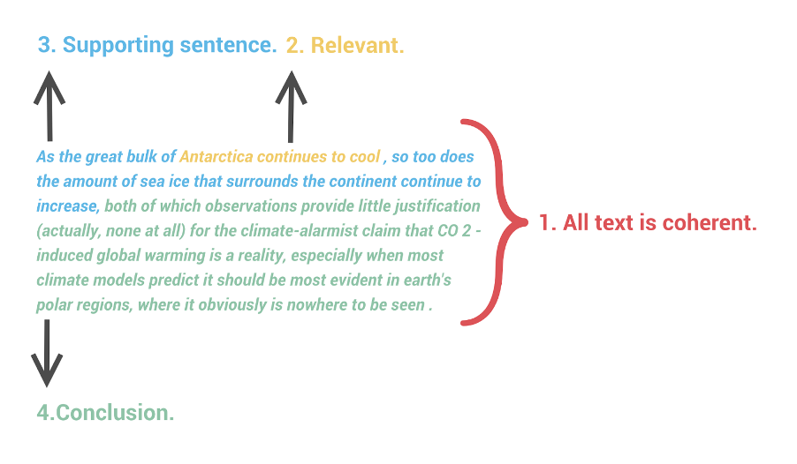

Approximately twenty sentences per sub-sub-claim were analysed and labelled by the criteria rules. If a sentence abided by all rules they were labelled as “structure present” (Appendix 7). If the sentence abided by most of the rules but broke either rule 3 or 4, they would be labelled as such, but highlighted in orange as an inferred part of the sentence could be added, from either the super claim or sub-claim, to give the sentence more structure. Lastly, when the sentence did not abide by rule 1 or 2, they were labelled as such and highlighted in red, to be excluded from being deconstructed. (Appendix 7).

# 

# Other stuff

## Journals for consideration

| JOURNAL | IF | OA | Fee | Notes |
| --- | --- | --- | --- | --- |
| Climatic Change | 4.743 | Y | USD$3860 |  |
| Environmental Research Letters | 6.9 | Y | $2080 |  |
| Global Challenges | 5.135 | Y | USD$3000 |  |
| Global Environmental Change | 10.4 | Y | $3500 |  |
| Global Sustainability | 5.4 | Y | USD$3255 |  |
| Human Communication Research | 5.333 | N |  |  |
| Nature Climate Change | 19.2 | Y | €9,500 ~AUD$14,000 | Nature Climate Change publishes original research across the natural and social sciences and strives to ***synthesize interdisciplinary research***.  main text of no more than 3,000 words and 6 display items |
| Nature Communications | 17.69 | N | $5380 |  |
| Nature Scientific Reports | 4.996 | N | $5380 |  |

Relevant papers (to help identify journals)

Banas, J. A., & Miller, G. (2013). Inducing Resistance to Conspiracy Theory Propaganda: Testing

Inoculation and Metainoculation Strategies: Metainoculation Strategies. Human Communication Research, 39(2), 184–207. https://doi.org/10.1111/hcre.12000

Boussalis, C., & Coan, T. G. (2016). Text-mining the signals of climate change doubt. Global Environmental Change, 36, 89–100. https://doi.org/10.1016/j.gloenvcha.2015.12.001

Coan, T. G., Boussalis, C., Cook, J., & Nanko, M. O. (2021). Computer-assisted classification of contrarian claims about climate change. Scientific Reports, 11(1), 22320. https://doi.org/10.1038/s41598-021-01714-4

Cook, J., Ellerton, P., & Kinkead, D. (2018). Deconstructing climate misinformation to identify reasoning errors. Environmental Research Letters, 13(2), 024018. https://doi.org/10.1088/1748-9326/aaa49f

Cook, J., Lewandowsky, S., & Ecker, U. K. H. (2017). Neutralizing misinformation through inoculation:

Exposing misleading argumentation techniques reduces their influence. PLOS ONE, 12(5), e0175799. https://doi.org/10.1371/journal.pone.0175799

Dai, A., Luo, D., Song, M., & Liu, J. (2019). Arctic amplification is caused by sea-ice loss under increasing CO2. Nature Communications, 10(1), 121. https://doi.org/10.1038/s41467-018-07954-9

Ding, D., Maibach, E. W., Zhao, X., Roser-Renouf, C., & Leiserowitz, A. (2011). Support for climate policy and societal action are linked to perceptions about scientific agreement. Nature Climate Change, 1(9), 462–466. https://doi.org/10.1038/nclimate1295

Lamb, W. F., Mattioli, G., Levi, S., Roberts, J. T., Capstick, S., Creutzig, F., Minx, J. C., Müller-Hansen, F.,

Culhane, T., & Steinberger, J. K. (2020). Discourses of climate delay. Global Sustainability, 3.

<https://doi.org/10.1017/sus.2020.13>

McCright, A. M., Dunlap, R. E., & Xiao, C. (2013). Perceived scientific agreement and support for government action on climate change in the USA. Climatic Change, 119(2), 511–518.

https://doi.org/10.1007/s10584-013-0704-9

van der Linden, S., Leiserowitz, A., Rosenthal, S., & Maibach, E. (2017). Inoculating the Public against Misinformation about Climate Change. Global Challenges, 1(2), 1600008. https://doi.org/10.1002/gch2.201600008

## Deleted content

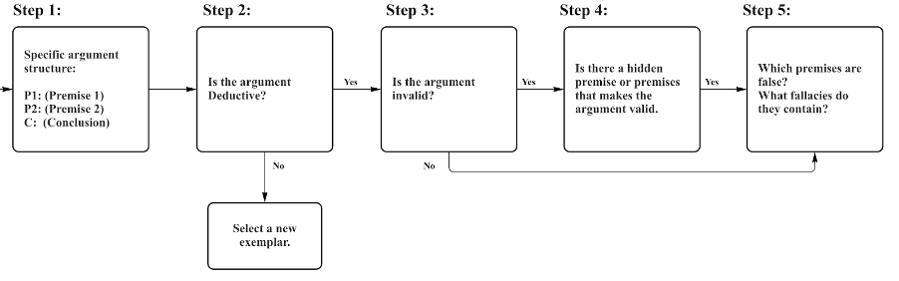

Figure 1: Five key steps used in the deconstruction methodology to identify logical fallacies in climate denialist claims (Cook et al. 2018).

Some existing examples of deployment strategies include: developing curriculum plans to be taught in classrooms (NationalCentre for Science Education 2022), gamification such as the Cranky Uncle smartphone game, which teaches and tests knowledge on fallacies (Roozenbek and Van der Linden 2018; Cook et al 2021), video lectures such as “Making sense of climate denial” from Massive Open Online Course (University of Queensland 2022) and the Cranky Uncle VS Climate Change Youtube series (Cook 2020).

Adopting a “logic-checking” approach is consistent with recent findings into logic-based inoculation. Inoculation theory or prebunking aims to expose individuals to a weakened form of misinformation, akin to immunisation against viruses (McGuire and Papageorgis, 1961; van der Linden, 2017; Cook et al., 2017). Existing literature found to warn of the threat of misinformation is effective in reducing the influence of misinformation before it is cognitively processed. Furthermore, fact-based and logic-based are considered both valid approaches to debunk misinformation and can be utilised in both spheres of pre-bunking or debunking efforts. Traditional fact-checking processes involve fact-based debunking as it disproves a claim by countering it with the factual or evidence-based explanations. The fact-based approach is most effective in dislodging misinformation when the misinformation is replaced with simpler and “stickier” factual information (Lewandowsky 2020). While logic-based, as mentioned in the previous section explains the logical fallacy in the denialist claim or argument (Cook et al., 2017). A study by Schmid and Betsch (2019) showed that both fact-based debunking and logic-based debunking are both effective in their own right. They also found that a combination of fact-based and logic-based had no more significant effect than using a singular strategy. However they concluded that logic-based debunking was a superior strategy to fact-based debunking as exposing misleading techniques can occur across disciplines, and thus can be more universally utilised against a multitude of arguments. Furthermore, specific to climate change misinformation a study by Cook et al. (2017) supports Schmid and Betsch’s findings. The 2017 study found that when countering myths concerning the consensus on climate change, both logic-based and fact-based debunking messages were effective in neutralising the misinformation.

Identifying fallacies in climate denialist claims exposes the misleading part of an argument to the audience. Exposing a fallacy promotes an individual to think critically about both current and future claims they may be presented with.

Cook (2020) expanded these five techniques into a more comprehensive taxonomy of rhetorical techniques, logical fallacies, and conspiratorial traits.

Depending on the given argument structure, multiple false premises may arise and each premise may contain multiple fallacies.

***Notes.*** *encompassing all the steps taken within this study to 1) prepare data 2) deconstruct the sub-sub-claims. Deconstruction: includes the five key deconstruction steps (Cook et al. 2018) and the deconstruction type categorisation for each of the sub-sub-claims examples and data analysed. Note more than two examples may be selected depending on the 1) the selection criteria and 2) the required deconstruction type.*

Responding to misinformation is a resource-intensive activity and there has been growing interest in using machine learning to automate the fact-checking process (Graves, 2019). Machine learning can be utilised in a plethora of ways to detect misinformation (Zhou & Zafarani, 2021).

Deconstructing misinformation as part of a broader, holistic framework offers a strategy to identify how climate denialist claims are misleading by identifying logical reasoning fallacies (Cook, 2022).

These findings promote future research questions of how fallacies interact within an argument.

A solution that is particularly promising is algorithmic fact-checking, where misinformation claims are detected and fact-checked in real-time (Cook, 2019; Lewandowsky et al., 2017). Nyhan and Reifler (2014) acknowledge that the mere presence of fact-checking disincentives those creating and spreading disinformation. However, traditional fact-checking is limited by the fact that misinformation can disseminate quickly before fact-checkers have time to manually detect and analyse misinforming claims. Graves (2017) concluded automated fact-checking is a far-fetched notion, and while he highlights the justified challenges, automated fact-checking for climate misinformation has been gaining successful traction (Boussalis and Coan 2016; Coan et al. 2021).

## Links

* [OFFICIAL GOOGLE SHEET OF DECONSTRUCTION WORKING](https://docs.google.com/spreadsheets/d/15_IM7pIYLj3TZpzScrnmI_nBqc6Cm7yfD4yu8LYZE-0/edit#gid=0)
* [Data selection (google sheet)](https://docs.google.com/spreadsheets/d/1hFcZalVqpeZvNeV4n4YfVVG87bF6Q7ti5evb_BUXV_I/edit#gid=981234686)
* [Draft deconstructions (google sheet)](https://docs.google.com/spreadsheets/d/1E0aNFm4ukf_gTvVmdGVId_L-yxngArNNSCNBtWt23aM/edit#gid=1293628267)
* [Simplified table / more final deconstruction (google doc)](https://docs.google.com/document/d/1-ZsGrtOns9YllBIKAUSrZ-7TH9OkSJrnpKaGz2mFFA0/edit#)
* [John’s first (failed) attempt to deconstruct CARDS](https://docs.google.com/document/d/1KGdnLSKuU__3rSC_HVygcPL-mrhFUBybwrqhpO6efOY/edit#)
* [Childless Sub-claim Data revision](https://docs.google.com/spreadsheets/d/177ree31tJoO7wbw4sNftU9op3krEX6RfsV6mQCiH0TA/edit#gid=0)

## Questions about google sheet deconstructions

* Supp Mat needs table of claims, # of example paragraphs, whether it was included or not
* Before you decide on a general/dominant argument, do you need to do the whole deductive/validity steps or is it just a matter of outlining the argument structure? And do you need the hidden premise? (if you do, then you do need deductive/validity)
* What’s going on with column J (premise analysis) - allocating true/false/partial/etc. Do we need that column? Are we using it to put scientific information and using column K for fallacy explanations.
  + What about premises that are definitely false?
  + Good to indicate which premises true
  + Maybe should true or misleading?
  + Change false to misleading in column J
* Greenhouse saturation (2.3.2) has the same exemplars as water vapour (2.3.4).
* 3.3.3 (plant food) is good case study for exploring conceptual difference between cherry picking and oversimplification - clarifying the difference.
* 4.1.3. (policy is bad for the environment) is more suited to “renewables are bad”
  + Maybe look at more paragraphs